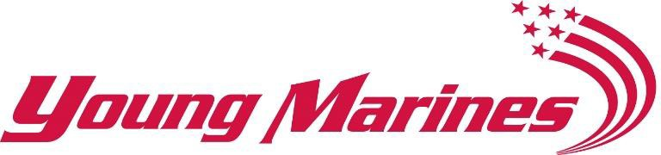

DRUG DEMAND REDUCTION (DDR) COORDINATOR – FULL TIME

Young Marines National Headquarters is seeking to fill a full-time salaried, exempt Drug Demand Reduction (DDR) Coordinator position to provide headquarters and field support functions for our drug prevention and awareness education efforts and DDR special projects. The DDR Coordinator would network and partner with federal, state and local stakeholders. Work with our membership to promote our drug awareness and prevention training efforts and evaluate the DDR programs effectiveness through measurable outcomes. Perform basic education and teaching functions such as DDR curriculum alignment, lesson planning, materials creation, and will be expected to work with both youth and adult members on training and education opportunities.

Schedule, Wage, and Benefit Information

- Full time position working under the direction of the Director of Operations
- Occasional schedule adjustments and travel at approximately 20% to accommodate in-service training, meetings, and field service training
- Medical/Dental Insurance
- 403(B) retirement plan
- Other optional employee supplemental insurance plans
- Salary commensurate with salaries for comparable positions in the Northern Virginia region

As the Drug Demand Reduction Coordinator, you will:

- Responsible for building and maintaining a positive image of the Young Marines program and build the capacity of its Drug Demand Reduction program (DDR)
- Serve as an organizational spokesperson on matters pertaining to the Young Marines DDR Program
- Conduct DDR stakeholder affairs with intergovernmental agencies, business, and private entities
- Direct/execute DDR promotional campaigns and events
- Oversee the development, procurement, and distribution of DDR education and promotional materials including Young Marines Content Management Website, web-based, and social media content
- Oversee/conduct communications for DDR related training with internal and external audiences including the public
- Oversee and execute DDR awards and recognition efforts
- Evaluate program/project activities on a quarterly basis

Desired qualifications include:

- Degree in education/psychology or related fields preferred, commensurate DDR experience will be considered, with significant practical experience
- Grant writing experience
- Proficient computer skills including SharePoint, Word, Outlook, Excel, PowerPoint, Teams, and Projects
- Ability to effectively communicate verbally and in writing
- Strong organizational skills, and ability to handle multiple tasks and meet deadlines
- Ability to lead, plan, and manage change
- Ability to excel in a fast-paced environment with changing priorities
- Demonstrated business acumen

Interested applicants should submit a cover letter and resume to the Director of Administration, Mrs. Patricia Borka via email, patricia.borka@youngmarines.org or via mail by sending to

Headquarters Young Marines 17739 Main Street, Suite 250
Dumfries VA. 22026
Attention: Director Administration

For questions, please call our office at 800-717-0060. Finalists will be asked for references.

Visit our website www.youngmarines.org to learn more about our organization.

Young Marines Inc. is an Equal Opportunity employer

The Young Marines strengthens the lives of America’s youth by teaching the importance of self- confidence, academic achievement, honoring our veterans, good citizenship, community service, and living a healthy, drug-free lifestyle. The Young Marines promotes the mental, moral, and physical development of its members. The program focuses on character building and leadership and promotes a lifestyle that is conducive to being productive members of society.

